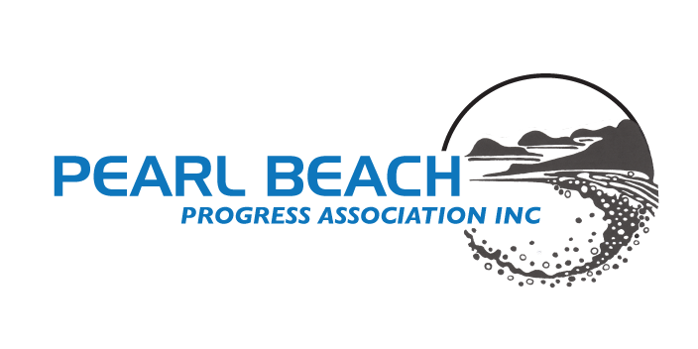**Media Release**

**Monday 20 January, 2025**

**Pearl Beach Celebrates**

**Family Fun on Sunday 26th January**

**8.30am - 12 noon**

Pearl Beach Progress Association has again put a lot of effort into celebrating a Family Fun Day on 26 January with the support of Central Coast Council. This is a tradition the small coastal village has upheld over many years. Visitors come from far and wide to share in the enjoyment, and the population almost doubles for the day.

Children’s races on the beach include age divisions as well as novelty events such as sack and 3-legged races, and a thong-throwing competition. A limited number of spots will be available for the sand-modelling event. The Rock-to-Rock run is always popular, when competitors will run twice the length of the beach. Registration starts at 8:30am, with the Rock-to-Rock scheduled for a 10:00am start. Be sure to bring a hat and sunscreen.

A barbecue sponsored by ACCOM Real Estate will be held with all proceeds going to the Mingaletta organisation in Umina. This year there will also be lamingtons and watermelon slices for sale. With the recent closure of the café and restaurant due to fire, the locals have arranged for a coffee van to be present each morning. Unless called away on emergencies, the local RFS will bring one of their fire trucks to the beach for children to see.

**End**: Publicity Officer, Pearl Beach Progress Association

**Photo: Having fun at the beach, last year**